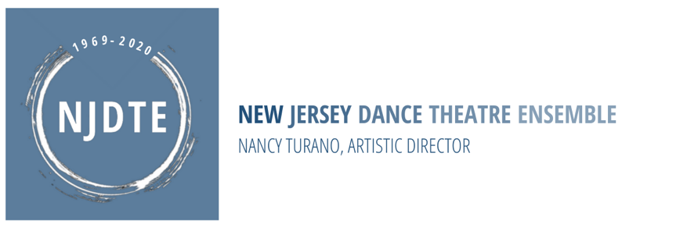

11/10/2021

**NJDTE** **2022 SPRING SEASON CALENDAR**

|  |  |
| --- | --- |
| **DATES** | **Weekday and Ensemble Calendar**  **Registration Dates/Performance & Events** |
| Wednesday, January 5th, 2022 | **First Day of 2021 Spring Weekday Classes** |
| Thursday, January 6th, 2022 | **40% Registration Deposit #2 Deadline for Weekday Classes and Ensemble Classes** |
| Saturday January 8th –  Sunday January 9th | **Spring Ensemble & Open Auditions** |
| Saturday January 15th –  Sunday January 16th | **Spring Ensemble & Open Auditions** |
| Saturday January 22nd 1:00pm – 4:00pm | **Spring Ensemble Photoshoot** For Select NJDTE Ensemble Dancers |
| Saturday January 29th 3:00pm – 6:00pm | **MIP2® Audition** |
| Saturday February 19th –  Sunday February 20th | **NJDTE Summer Programming Auditions** |
| Tuesday March 1st, 2022 | **20% Registration Final Deposit Deadline for Weekday Classes and Ensemble Classes** |
| Monday, April 11-Sunday, April 17th | **NJDTE CLOSED for Spring Break** |
| April 23rd – 24th, 2022  April 30th – May 1st, 2022 | **TBA NJDTE Ensemble Balli di Primavera! The Dances of Spring**  Mandatory Rehearsals & Performance |
| Monday, May 30th, 2022 | **NJDTE CLOSED for Memorial Day** |
| Saturday, May 21st –  Friday, May 27th 2022 | **NJDTE Parent Observation Week TBA Via Zoom** |
| Saturday, June 4th, 2022 | **Last Day of 2021 Spring Weekday Classes** |
| Sunday, June 5h, 2022 | **NJDTE 53rd Anniversary Fundraiser Performance & Event** |